**An Industry Oriented Mini Project**

**On**

**MOBILE SHOPPING TRIAL ROOM**

Project Report Submitted in partial fulfillment

of the requirement for the award of the degree of

**BACHELOR OF TECHNOLOGY**

**In**

**COMPUTER SCIENCE AND ENGINEERING**

**By**

**Santhosh Raj S.I. 11951A0572**

**Sai Tarun S. 11951A05A2**

**Sandeep B. 11951A05A5**

**Yadagiri B. 11951A05B7**

Under the esteemed guidance of

**Ms. J. Rajani**

Associate Professor



**COMPUTER SCIENCE AND ENGINEERING**

**INSTITUTE OF AERONAUTICAL ENGINEERING**

Dundigal, Hyderabad - 500 043

**COMPUTER SCIENCE AND ENGINEERING**

**INSTITUTE OF AERONAUTICAL ENGINEERING**

Dundigal, Hyderabad - 500 043



**CERTIFICATE**

This is to certify that the project entitled “**MOBILE SHOPPING TRIAL ROOM**” is a bonafide one being carried out at Institute of Aeronautical Engineering, Dundigal by

**Santhosh Raj S.I. 11951A0572**

**Sai Tarun S. 11951A05A2**

**Sandeep B. 11951A05A5**

**Yadagiri B. 11951A05B7**

of B. Tech IV Year II Semester as a partial fulfilment of acedamic requirement for the award of B.Tech. degree in Computer Science and Engineering discipline during 2014-2015.

**Internal Supervisor Head of the Department**

**Ms. J. Rajani Prof. L.V. Narasimha Prasad**

Associate Professor Professor and Head

Department of CSE Department of CSE

IARE, Dundigal IARE, Dundigal

**Internal Examinar External Examinar**

**ACKNOWLEDGEMENT**

The satisfaction that accompanies the successful completion of any task would be incomplete without the mention of the people who made it possible and whose constant guidance and encouragement crown all the efforts with success. We thank our college management and

**Sri M. Rajashekar Reddy,** Chariman, I.AR.E, Dundigal for providing us the necessary infrastructure to carry out the project work.

We express our sincere thanks to Prof. **L.V Narasimha Prasad**, Professor and Head, Department of CSE, who has been a great source of information for our work and to our beloved Principal, **Dr. A. Barai** for extending his support to carry on this project work.

We are especially thankful to our internal supervisor **Ms. J. Rajani**, Associate Professor, Department of CSE, for her internal support and professionalism who helped us in shaping the project into successful one.

We take this opportunity to express our thanks to one and all who directly or indirectly helped us in bringing this effort to present form.

Santhosh Raj S.I. 11951A0572

Sai Tarun S. 11951A05A2

Sandeep B. 11951A05A5

Yadagiri B. 11951A05B7

**CONTENTS**

**TITLE PAGE NO.**

Abstract

1. Introduction 1
2. Existing System 2
3. Proposed System 3
4. Design 4
5. Implementation 6
6. Test Case 13
7. Results 14
8. Applications 17
9. Conclusion and Future Enhancements 18
10. References 19

**LIST OF TABLES**

**TITLE PAGE NO.**

Table 1: Test cases 13

**LIST OF FIGURES**

**TITLE PAGE NO.**

Figure 1 13

Figure 2 13

Figure 3 14

Figure 4 14

Figure 5 15

**Abstract**

Usually when people go for shopping, they choose few products like shirts, t-shirts, tops, trousers, etc., and then look for a trail room go there, have a physical trail of the selected products and then check whether these products suits them or not. After this if they find these products suits them, they can go for billing of those products. But if they find that those products does not suit them they again need to go for few other products and repeat the same procedure. Also people find difficulty while shopping for their family member, relatives, and friends etc., to overcome all such problems we created an application which people can use in their mobile and make their shopping bit easy. During shopping when a person selects some shirt or a trouser he can just scan the QR-CODE which is tagged to the corresponding product, then the application makes product as a fore ground image and user’s image as a background image and thus make a visual as if user is really wearing that item.

Introduction

**1. Introduction**

* People regard shopping as a fun and joyous task.
* But when it comes to shopping of clothing product much care and attention is required as it is well known fact that such material is bought with regard for taste and tailored sizes.
* Having trial rooms for purposes to put on any clothing product is good way to attract customers.
* But certain limitations are observed in physical world.
* The proposed app is an android based application which is an attempt to bring augmented reality much closer to users and benefit both commercial aspect as well as customer satisfaction.
* This app begins with an idea from augmented reality.
* Augmented reality (AR) is a live direct or indirect view of a physical, real-world environment whose elements are augmented (or supplemented) by computer-generated sensory input such as sound, video, graphics or GPS data. Simply put, it is the convergence point of virtual world with real world.
* So from this concept comes a commercial aspect of bringing shopping in a manner that both the costumers and the business loves it.
* our application deals with much smaller aspect of cloth and other wearable products in this huge augmented shopping world, but is a much personal and cared for product in all of shopping products.

1

Existing System

**2. Existing System**

* Our physical world is itself the existing system
* If any one goes shopping, he or she selects few products. Then he/she will see for a trail room, then if they find a trail room they go there and try the product and then should check whether it suits them or not.
* And again, if he want to trial some other product he has to repeat the entire process.
* If the product do suit him, then he can purchase it.
* Even some clothes are not allowed for trial like formal shirts,white shirts,etc.
* There is also a problem of heavy crowd during festive season and at that time, trialing multiple clothes is almost a tedious task.
* Security is the major concern in this system.
* Hidden cameras in trial rooms is the serious issue to be considered for the female customers.
* Owner's risk is also an issue to be considered and he will be left as a victim for any loss or damae of the products.
* And if any legal problem is encountered he may be considered as a victim and the
* Shop may be ceased if any insider or outsider brings a hidden camera and fix it in any of the trial rooms because later on it may be used in any unsocial/illegal activity without the knowledge of the shop owner.
* A lot of shoppers have encountered a lot of problems while shopping at a high-end place for readymade garments, especially during peak hours, such as weekends. Tiresome lines, numerous restrictions, enormous crowds make it quite an unpleasant experience.
* Huge number of customers, and minimum numbers of trial rooms results in quite a lot of waiting time for customers, ultimately resulting in dissatisfaction.
* Due to security reasons, there is also a restriction on the number of garments that can be taken at one instance of time for trial. It increases the overall shopping time due to multiple trips from the shelves to the trial rooms.
* From the boutique’s point of view, a large percentage of thefts happen because of sneaking in garments while in the trial room. Also they are unable to show the customers the fresh stock that is supposed to be delivered to the shop in the coming few days.

2

Proposed System

**3. Proposed System**

* This application runs on android devices which is most popular and widespread.
* The application is personal to each user who makes a profile on his/her device.
* Information of each product is tagged with QR code itself or this QR code could be used to fetch information about the product from internet.
* The application now having a profile and product information creates a visual on user device, appearing as if the user is really wearing that product.
* If visuals created are good enough we could eliminate the need of trial rooms.

3

Design

**4. Design**

**4.1 PROFILE CREATION:**

* In this step, we can perform two different operations:

1. Creating Profile and
2. Selecting Profile.

* When we go for Create Profile, here we need to register ourself. For this we have to enter our name,select gender and after that we need to select a picture from gallery of that device which we had taken before.After that we have to click on registor button to compleate the registration process.Then, a Profile is created from the data we had given.
* When we click on Select Profile,First here we can select a profile from already created profiles which we has done using Create Profile button.So, if we go for Select Profile we need not create Profile again, we can directly use the already existing Profiles.

**4.2 QR CODE SCANNING:**

* In this step,when a product is taken it has a tag attached to it.
* This tag contains a QR code attached to it.
* This QR code contains the URL.
* This URL consists of the information of the product along with the image of the product.
* And here,we scan the code attached through the camera.
* QR code scanner is used to scan a QR code.
* When the scan is successful the image of product is retrieved into the device.

4

**4.3 CREATING A VISUAL:**

* In this step,it merges the two steps i.e., it uses the picture slected from the gallery and the image of the product.
* In this screen, we have two layers of which the above layer has the image of ythe product and the other contains the selected picture.
* Now, we need to adjust the image on to the selected picture.
* And here, we have three buttons Zoom in,Zoom out and Screenshot.
* Zoom in and Zoom out are used for adjusting the image of the product and Screenshot is used to take the screenshot after adjusting it properly.

5

Implementation

**5. Implementation**

import java.io.File;

import java.io.FileNotFoundException;

import java.io.FileOutputStream;

import java.io.IOException;

import java.net.URL;

import android.app.Activity;

import android.content.Context;

import android.graphics.Bitmap;

import android.graphics.BitmapFactory;

import android.graphics.Canvas;

import android.graphics.Color;

import android.graphics.Paint;

import android.graphics.PixelFormat;

import android.graphics.Bitmap.CompressFormat;

import android.graphics.drawable.Drawable;

import android.os.Bundle;

import android.os.Environment;

import android.view.Menu;

import android.view.MenuItem;

import android.view.MotionEvent;

import android.view.SurfaceHolder;

import android.view.SurfaceView;

import android.view.View;

import android.view.View.OnClickListener;

import android.view.View.OnTouchListener;

import android.view.ViewGroup.LayoutParams;

import android.widget.Button;

6

public class SurfaceClass extends Activity implements SurfaceHolder.Callback {

DrawOnTop mDraw;

SurfaceView surfaceView;

SurfaceHolder surfaceHolder;

String itemurl;

Button cap;

private static final int MENU_ITEM_1 = Menu.FIRST + 1;

private static final int MENU_ITEM_2 = Menu.FIRST + 2;

private static final int MENU_ITEM_3 = Menu.FIRST + 3;

protected void onCreate(Bundle savedInstanceState) {

// TODO Auto-generated method stub

super.onCreate(savedInstanceState);

setContentView(R.layout.main1);

mDraw = new DrawOnTop(SurfaceClass.this);

addContentView(mDraw, new LayoutParams(LayoutParams.WRAP_CONTENT,

LayoutParams.WRAP_CONTENT));

getWindow().setFormat(PixelFormat.UNKNOWN);

surfaceView = (SurfaceView) findViewById(R.id.surfaceview);

surfaceHolder = surfaceView.getHolder();

surfaceHolder.addCallback(this);

String imageurl = getIntent().getStringExtra("imageurl");

itemurl = getIntent().getStringExtra("itemurl");

Drawable d = Drawable.createFromPath(imageurl);

surfaceView.setBackgroundDrawable(d);

surfaceHolder.setType(SurfaceHolder.SURFACE_TYPE_PUSH_BUFFERS);

surfaceView.setDrawingCacheEnabled(true);

}

7

public void surfaceChanged(SurfaceHolder holder, int format, int width,

int height) {

// TODO Auto-generated method stub

}

public void surfaceCreated(SurfaceHolder holder) {

// TODO Auto-generated method stub

}

public void surfaceDestroyed(SurfaceHolder holder) {

// TODO Auto-generated method stub

}

class DrawOnTop extends View implements OnTouchListener {

float x = 30, y = 30;

int a1 = 250, b1 = 250;

Canvas tempcanvas = null;

Bitmap bitmap = null;

Bitmap b;

public DrawOnTop(Context context) {

super(context);

// TODO Auto-generated constructor stub

setOnTouchListener(DrawOnTop.this);

}

8

protected void onDraw(Canvas canvas) {

// TODO Auto-generated method stub

Paint paint = new Paint();

paint.setStyle(Paint.Style.FILL);

paint.setColor(Color.RED);

try {

bitmap = BitmapFactory.decodeStream(new URL(itemurl)

.openConnection().getInputStream());

} catch (Exception e) {

// TODO Auto-generated catch block

e.printStackTrace();

}

b = Bitmap.createScaledBitmap(bitmap, a1, b1, true); // canvas

canvas.drawBitmap(b, this.x, this.y, null);

tempcanvas = canvas;

super.onDraw(tempcanvas);

}

public void ZoomIn() {

a1 = a1 + 40;

b1 = b1 + 40;

b = Bitmap.createScaledBitmap(bitmap, a1, b1, true);

tempcanvas.drawBitmap(b, x, y, null);

postInvalidate();

}

9

public void ZoomOut() {

a1 = a1 - 40;

b1 = b1 - 40;

b = Bitmap.createScaledBitmap(bitmap, a1, b1, true);

tempcanvas.drawBitmap(b, x, y, null);

postInvalidate();

}

public boolean onTouchEvent(MotionEvent event) {

// TODO Auto-generated method stub

switch (event.getAction()) {

case MotionEvent.ACTION_DOWN: {

}

break;

case MotionEvent.ACTION_MOVE: {

x = (int) event.getX();

y = (int) event.getY();

invalidate();

}

break;

case MotionEvent.ACTION_UP:

x = (int) event.getX();

y = (int) event.getY();

System.out.println(".................." + x + "......" + y); // x=

// 345

// y=530

invalidate();

break;

}

return true;

}

10

public boolean onTouch(View v, MotionEvent event) {

// TODO Auto-generated method stub

return false;

}

}

public boolean onCreateOptionsMenu(Menu menu) {

menu.add(Menu.NONE, MENU_ITEM_1, Menu.NONE, "ZoomIn").setIcon(

R.drawable.zoomin);

menu.add(Menu.NONE, MENU_ITEM_2, Menu.NONE, "ZoomOut").setIcon(

R.drawable.zoomout);

menu.add(Menu.NONE,MENU_ITEM_3,Menu.NONE,"ScreenCapture").setIcon(

R.drawable.screencapture);

return super.onCreateOptionsMenu(menu);

}

public boolean onOptionsItemSelected(MenuItem item) {

switch (item.getItemId()) {

case MENU_ITEM_1:

mDraw.ZoomIn();

break;

case MENU_ITEM_2:

mDraw.ZoomOut();

break;

case MENU_ITEM_3:

captureScreen();

break;

11

}

return true;

}

private void captureScreen() {

View v = getWindow().getDecorView().getRootView();

v.setDrawingCacheEnabled(true);

Bitmap bmp = Bitmap.createBitmap(v.getDrawingCache());

v.setDrawingCacheEnabled(false);

try {

FileOutputStream fos = new FileOutputStream(new File(Environment

.getExternalStorageDirectory().toString(), "SCREEN"

+ System.currentTimeMillis() + ".png"));

bmp.compress(CompressFormat.PNG, 100, fos);

fos.flush();

fos.close();

} catch (FileNotFoundException e) {

e.printStackTrace();

} catch (IOException e) {

e.printStackTrace();

}

}

}

12

Test Case

**6. Test Case**

|  |  |  |  |  |
| --- | --- | --- | --- | --- |
| **Test case ID** | **Test case** | **Expected behavior** | **Exhibiting behavior** | **Result** |
| 1 | Trying to select profile when there are no profiles | Should display a message. | Message is displayed that there are no profiles. | Success |
| 2 | Trying to select a picture from gallery where there are no pictures | Should display a message | Message is displayed that there are no pictures | Success |
| 3 | QR code not containing URL for image | Should display a message | Message is displayed to scan a proper QR code. | Success |
| 4 | Trying to scan QR code when there are existing applications for scanning QR codes | Should displays all such applications | List of all scanning applications are displayed. | Success |
| 5 | Trying to take the screenshots when there is no sufficient space. | Should display a message. | Message is displayed "Insufficient storage space." | Success |
|  |  |  |  |  |

Table 1:test cases

13

Results

**7. Results**

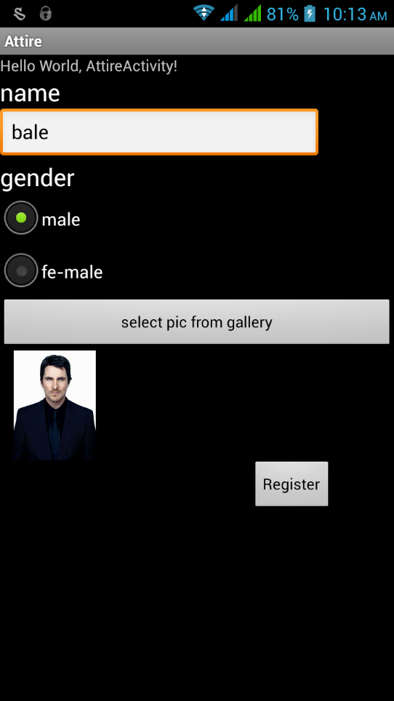

Figure 1 Figure 2

14

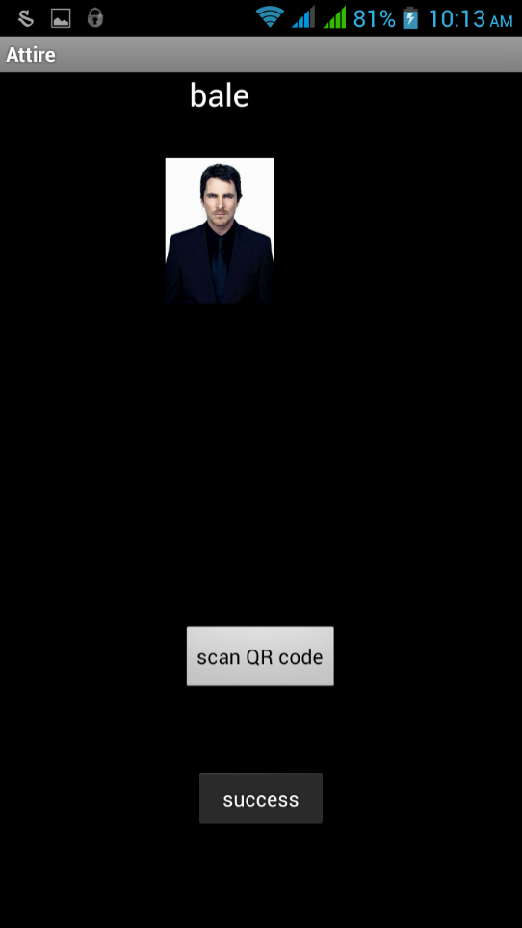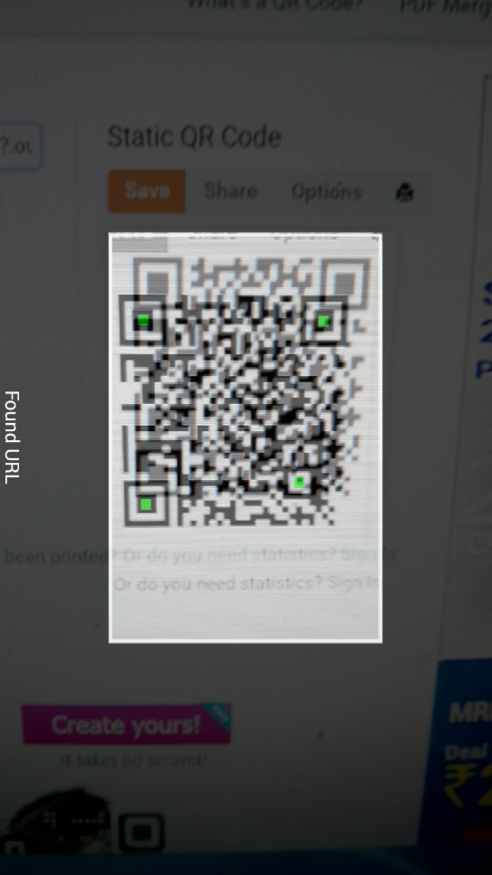

Figure 3 Figure 4

15

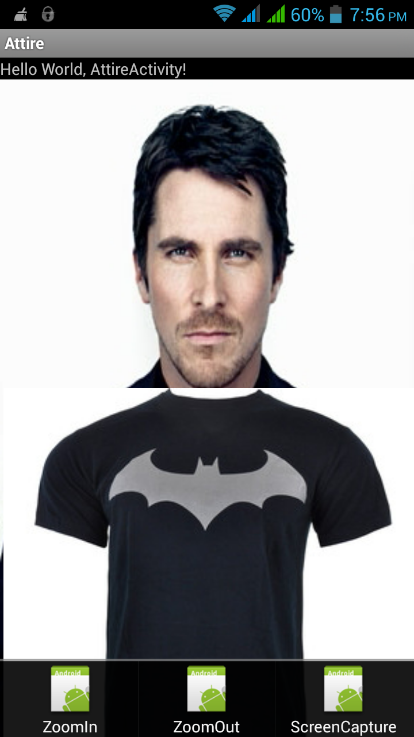

Figure 5

16

Applications

**8. Applications**

This project brings in new world towards costumer interaction. It has widespread application in commercial world .With advent of augments reality it is likely similar application can be build of other commercial aspects for example home décor –the application would create a visual of furniture be used to mine knowledge from data collected from users. This could further help sellers understand costumers better & help achieve greater sales targets.

17

Conclusion and Future Enhancements

**9. Conclusion and Future Enhancements:**

**Conclusion:**

Augmented reality application using Android operating system which will help to combine virtual objects with the real environment facilitating various applications. The main advantage is use of low cost devices as compared to the costly head mounted display devices. Secondly with the help of this project you need not buy product and then see how it will suit your environment.

**Future Enhancements:**

In future images of objects from various views can be fetched directly from vendor’s websites, same could be modelled into a 3D objects and augmented.By which it will be 3D interface will be obtained. Also multiple objects will be augmented which is currently a major challenge.

18

References

11. References

[1] Rencheng Sun , YiSui , RanLi , Fengjing Shao, The Design of a New Marker in Augmented Reality, 2011 International Conference on Economics and Finance Research , IPEDR vol.4 (2011) © (2011)IACSIT Press, Singapore.

[2] Si Jung Jun Kim, A User Study Trends in Augmented Reality and Virtual Reality Research, 2012 International Symposium on Ubiquitous Virtual Reality.

[3] Evaluation of Augmented Reality Frameworks for Android Development

Iulia Marneanu, Martin Ebner, Thomas Roessler.

[4] Markerless Augmented Reality Android App for Interior Decoration

Prasad Renukdas, Rohit Ghundiyal, Harshavardhan Gadgil, Vishal Pathare.

[5]R. Azuma, Y. Baillot, R. Behringer, S. Feiner, S. Julier, and B. MacIntyre. Recent Advances in Augmented Reality. Journal IEEE Computer Graphics and Applications. Vol. 1(6), pp. 34-47, 2001.

[6]D. Schmalstieg, T. Langlotz, and M. Billinghurst. Augmented Reality 2.0. In: Virtual Realities. Coquillart, S., Brunnett, G., and Welch, G. Springer, Germany, pp. 13-37, 2011.

[7] R. Azuma. A Survey of Augmented Reality. Presence: Teleoperators and Virtual Environments, Vol. 6(4), pp. 355-385, 1997.

[8] S. Yuen, G. Yaoyuneyong, and R. Johnson. Augmented reality: An overview and five directions for AR in Education. Journal of Educational Technology Development and Exchange. Vol. 4(1), pp. 119-140, 2011.

19